**APEX COLLEGE**

**POKHARA UNIVERSITY**

**LAB REPORT OF**

**DOT NET TECHNOLOGY**

**LAB -3 and 4**

**Submitted By: Submitted To:**

**Remisha Maharjan Bishwomitra Adhikari**

**BCIS ‘Adware’ Ananta Pant**

**Roll no: 17**

**OBJECTIVE:-**

-CREATING A FOLDER D:\APEXRESTAURANT\AND INITIALIZE PROJECTS

-USING GITHUB

1. **ValuesController.cs**

using System;

using System.Collections.Generic;

using System.Linq;

using System.Threading.Tasks;

using Microsoft.AspNetCore.Mvc;

using Microsoft.Extensions.Logging;

namespace lab3_mvc.Api.Controllers

{

    [ApiController]

    [Route("[controller]")]

    public class ValuesController : ControllerBase

    {

        [Route("Index")]

        public IActionResult Index()

        {

            var Name="Remisha";

            return Ok(Name);

        }

    }

}

1. **WeatherForecastController.cs**

using System;

using System.Collections.Generic;

using System.Linq;

using System.Threading.Tasks;

using Microsoft.AspNetCore.Mvc;

using Microsoft.Extensions.Logging;

namespace lab3_mvc.Api.Controllers

{

    [ApiController]

    [Route("[controller]")]

    public class WeatherForecastController : ControllerBase

    {

        private static readonly string[] Summaries = new[]

        {

            "Freezing", "Bracing", "Chilly", "Cool", "Mild", "Warm", "Balmy", "Hot", "Sweltering", "Scorching"

        };

        private readonly ILogger<WeatherForecastController> _logger;

        public WeatherForecastController(ILogger<WeatherForecastController> logger)

        {

            _logger = logger;

        }

        [HttpGet]

        public IEnumerable<WeatherForecast> Get()

        {

            var rng = new Random();

            return Enumerable.Range(1, 5).Select(index => new WeatherForecast

            {

                Date = DateTime.Now.AddDays(index),

                TemperatureC = rng.Next(-20, 55),

                Summary = Summaries[rng.Next(Summaries.Length)]

            })

            .ToArray();

        }

    }

}

**Output:**

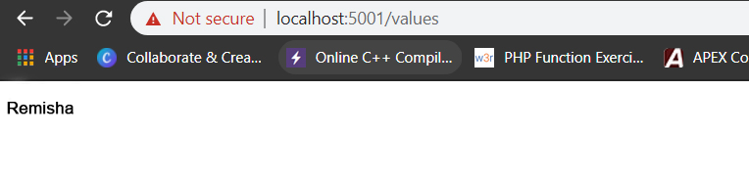

**Conclusion:**

In lab 3 and 4 we learned to create a project called ApexRestaurant (lab3_mvc).